**1.INTRODUCTION**

**1.1 Overview**

The Global Air Transportation Network dataset is a comprehensive collection of information on airports, airlines and their routes.

**1.2 purpose**

The purpose of air transport lies in its ability as an economic engine to generate and support jobs, strengthen trade and connectivity between people and countries, promote tourism, and connect remote communities .

**PROBLEM DEFINITION & DESIGN THINKING**

**2.1 EMPATHY MAP:**

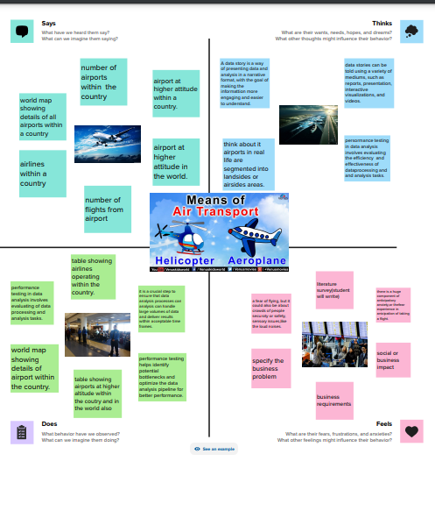

**2.2 IDEATION & BRAINSTORMING MAP**

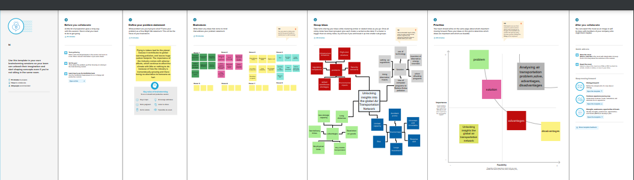

**RESULT**

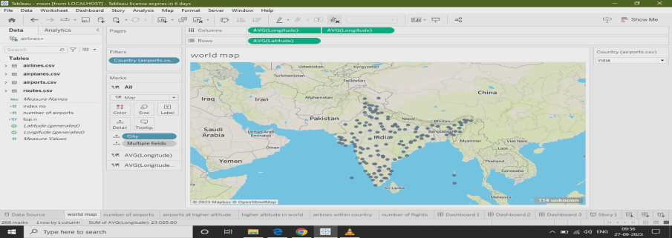



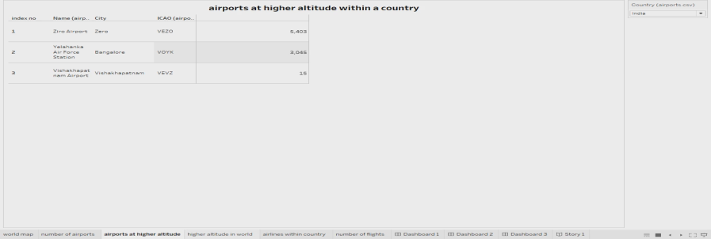

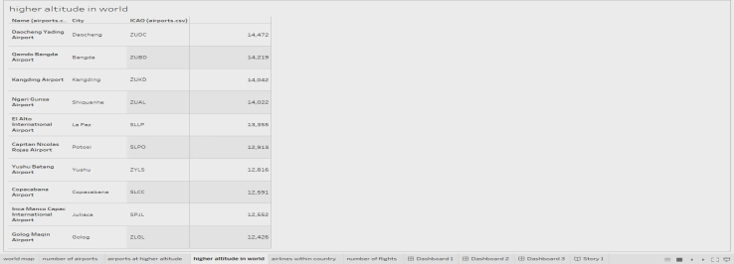

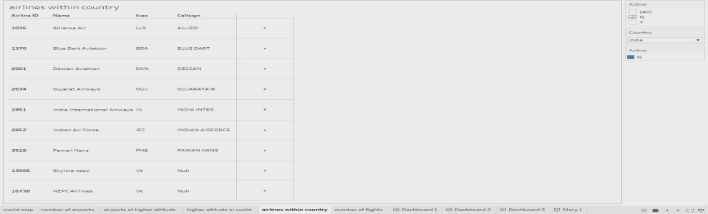

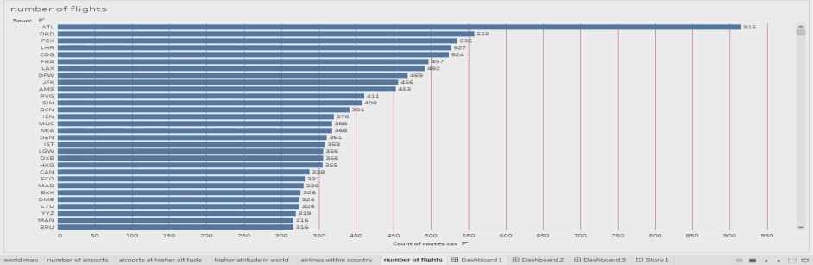

**ADVANTAGES & DISADVANTAGES**

**Advantages of Air Transport:**

* **High Speed. Air is the type of freight capable of traveling long distances in short periods of time.**
* **Fast Service.**
* **High Standard of Security.**

**Disadvantages of Air Transport**

**High Cost. This is significantly more costly for its services than land, rail, and water transportation.**

**Risky.**

**limited capacity. .**

**Uncertain and Unreliable**

**APPLICATIONS**

Air transport allows people from different countries to cross international boundaries and travel other countries for personal, business, medical, and tourism purposes.

**CONCLUSION**

Air freight is a fast, flexible, and efficient shipping method that provides businesses with numerous benefits, including speed, flexibility, efficiency, and reduced risk of damage or loss.

**FUTURE SCOPE**

Emerging technologies are reshaping with robotics, artificial intelligence, the internet of things, unmanned aircraft systems and the push for hybrid and electric airplanes – just to name a few.